Test for Help View Page

A test video has been created and available at this [link](https://interact2.csu.edu.au/webapps/blackboard/execute/groupFileExchange?course_id=_68847_1&group_id=_84856_1).

GitHub link for [Help View Page](https://github.com/commet003/ITC303-9-Team1-Project/blob/testing/ADHDTaskManagerApp/app/src/main/java/com/csu_itc303_team1/adhdtaskmanager/HelpScreen.kt).

**Note**: A slow internet connection may result in an error as a result of delay in loading, especially for the pdf files and the video.

Screen shot.

1. Main page
   1. 3 items

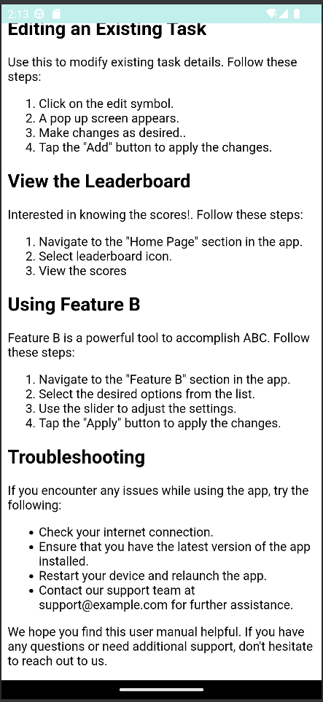

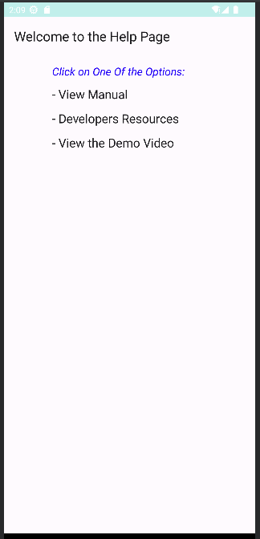

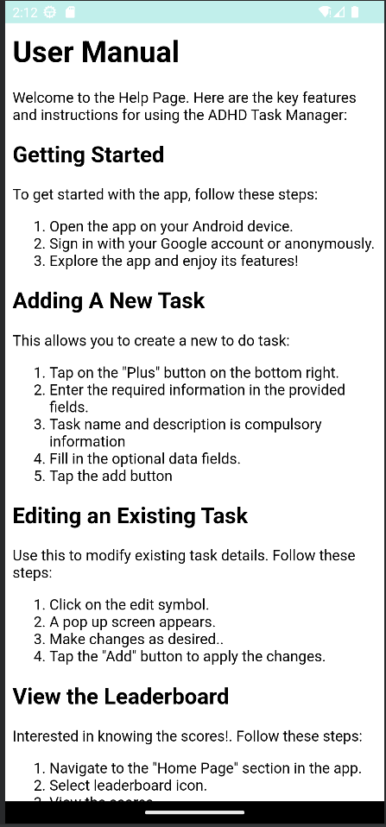

1. Inside the view manual there is:
   1. getting started tip
   2. basic useful features
   3. trouble shooting tips
2. Developers Resources

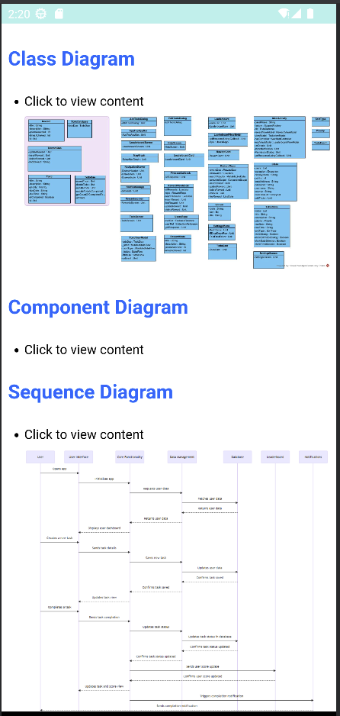

Figure b

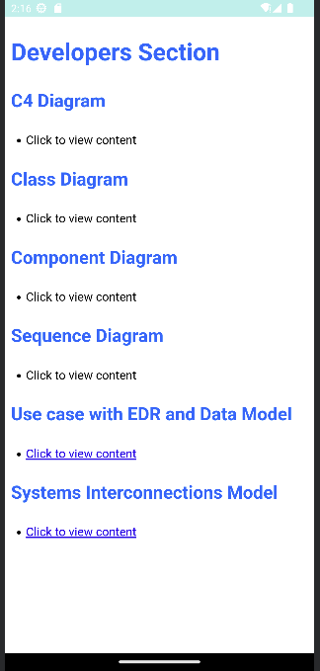

Figure a

* 1. figure a shows the documents available.
  2. Examples of some of the documents

(figure b).

* 1. clicking again on *click to view content*

closes the diagram

* 1. The emulator back button loads the main

page.

1. Demo Video
   1. Clicking on *View the Demo Video*

opens the YouTube link.

